DSA0504-QUERY PROCESSING FOR DATA SCIENCE
Name:Prithika BH
Reg No:192424403
Lab Experiments

Experiment 1: Data Wrangling Using Pandas Concatenation (Merge Operation)
Aim
To write a Python program using the Pandas library to concatenate (merge) two DataFrames row-wise using the concat() function.
Algorithm
- Import the pandas library.
- Create the first dictionary containing employee details.
- Create the second dictionary containing employee details with salary information.
- Convert both dictionaries into separate DataFrames.
- Concatenate the two DataFrames using pd.concat() along axis = 0 (row-wise).
- Display the concatenated DataFrame.
Code
# Import pandas module
import pandas as pd
# Define first dictionary
data1 = {
'Name': ['Jai', 'Princi', 'Gaurav', 'Anuj'],
'Age': [27, 24, 22, 32],
'Address': ['Nagpur', 'Kanpur', 'Allahabad', 'Kannuaj'],
'Qualification': ['Msc', 'MA', 'MCA', 'Phd'],
'Mobile No': [97, 91, 58, 76]
}
# Define second dictionary
data2 = {
'Name': ['Gaurav', 'Anuj', 'Dhiraj', 'Hitesh'],
'Age': [22, 32, 12, 52],
'Address': ['Allahabad', 'Kannuaj', 'Allahabad', 'Kannuaj'],
'Qualification': ['MCA', 'Phd', 'Bcom', 'B.hons'],
'Salary': [1000, 2000, 3000, 4000]
}
# Create first DataFrame
df = pd.DataFrame(data1, index=[0, 1, 2, 3])
# Create second DataFrame
df1 = pd.DataFrame(data2, index=[4, 5, 6, 7])
# Concatenate the DataFrames
res = pd.concat([df, df1], axis=0)
# Display the result
print("Concatenated DataFrame:")
print(res)
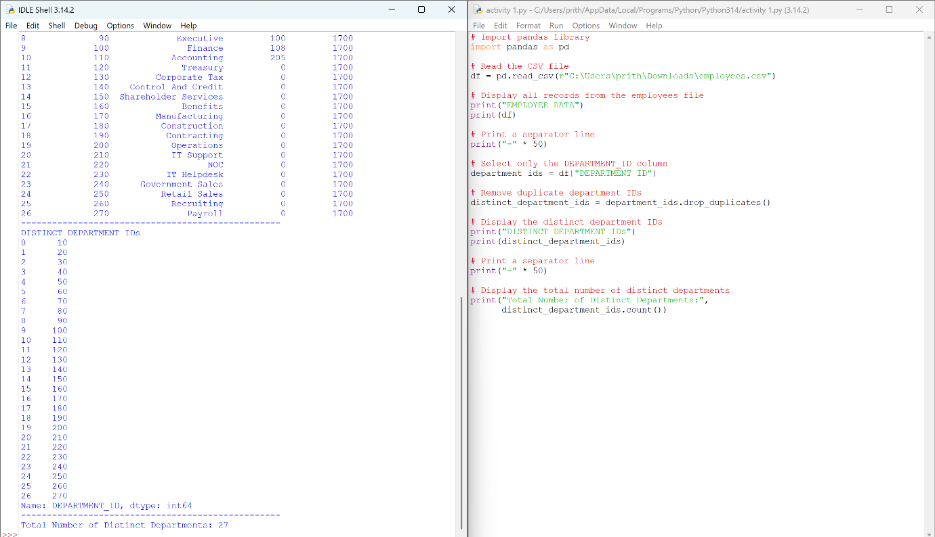
Output
Result
The two DataFrames were successfully concatenated row-wise using the pd.concat() function. Columns that were not present in one DataFrame contain NaN (Not a Number) values in the merged output.

Experiment 2: Display the IDs of Employees Who Have Done Two or More Jobs in the Past
Aim
To write a Python program using the Pandas library to display the IDs of employees who have done two or more jobs in the past using the value_counts() function.
Algorithm
- Import the pandas library.
- Read the job_history.csv file into a DataFrame.
- Display the job history data.
- Count the number of occurrences of each EMPLOYEE_ID using value_counts().
- Select the employee IDs whose count is greater than or equal to 2.
- Display the employee IDs who have done two or more jobs.
- Display the total number of such employees.
Code
# Program to display the IDs of employees who have done
# two or more jobs in the past
# Import pandas library
import pandas as pd
# Read the CSV file
df = pd.read_csv(r"C:\Users\prith\Downloads\job_history.csv")
# Display the complete data
print("JOB HISTORY DATA")
print(df)
print("-" * 50)
# Count the number of jobs done by each employee
job_count = df["EMPLOYEE_ID"].value_counts()
# Select employees who have done two or more jobs
employees = job_count[job_count >= 2]
# Display employee IDs
print("Employees who have done two or more jobs:")
for emp_id in employees.index:
print(emp_id)
print("-" * 50)
# Display total number of employees
print("Total Employees:", len(employees))
Output
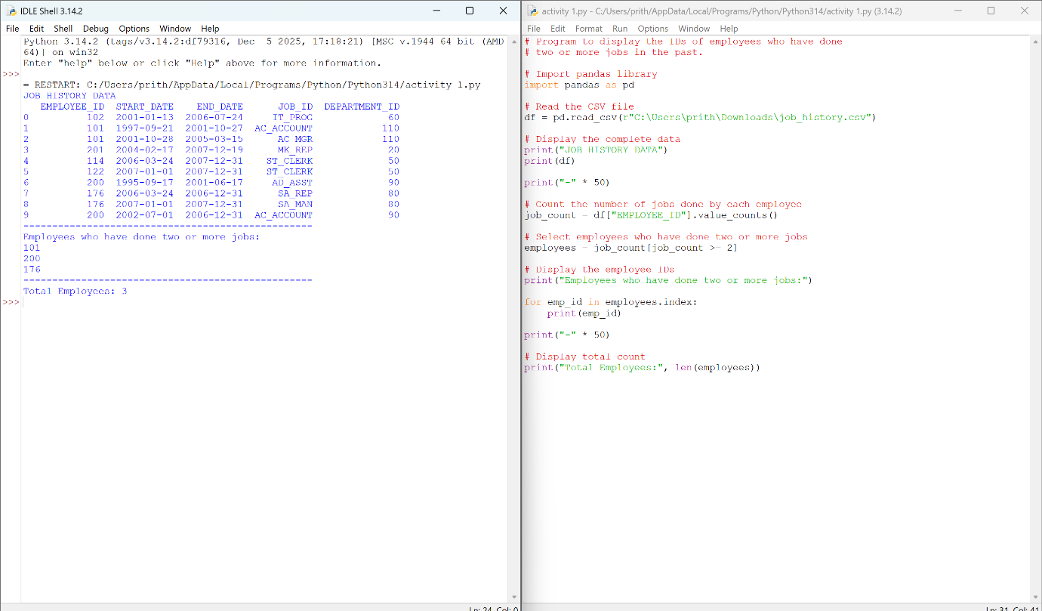
Result
The program successfully identified the employee IDs of employees who have performed two or more jobs in the past using the Pandas value_counts() function. The employees identified are 101, 176, and 200. The program successfully identified the employee IDs of employees who have performed two or more jobs in the past using the Pandas value_counts() function. The employees identified are 101, 176, and 200.

Experiment 3: Display the Details of Jobs in Descending Order of Job Title
Aim
To write a Python program using the Pandas library to display the details of jobs in descending order based on the JOB_TITLE column.
Algorithm
- Import the pandas library.
- Read the jobs.csv file into a DataFrame.
- Display the original job details.
- Sort the DataFrame in descending order using the JOB_TITLE column with the sort_values() function.
- Display the sorted DataFrame.
- Display the total number of jobs.
Code
# Program to display the details of jobs in descending order of JOB_TITLE
# Import pandas library
import pandas as pd
# Read the CSV file
df = pd.read_csv(r"C:\Users\prith\Downloads\jobs.csv")
# Display the original data
print("JOB DETAILS")
print(df)
print("-" * 60)
# Sort the DataFrame in descending order based on JOB_TITLE
sorted_jobs = df.sort_values(by="JOB_TITLE", ascending=False)
# Display the sorted data
print("JOB DETAILS IN DESCENDING ORDER OF JOB TITLE")
print(sorted_jobs)
print("-" * 60)
# Display total number of jobs
print("Total Number of Jobs:", len(sorted_jobs))
Output
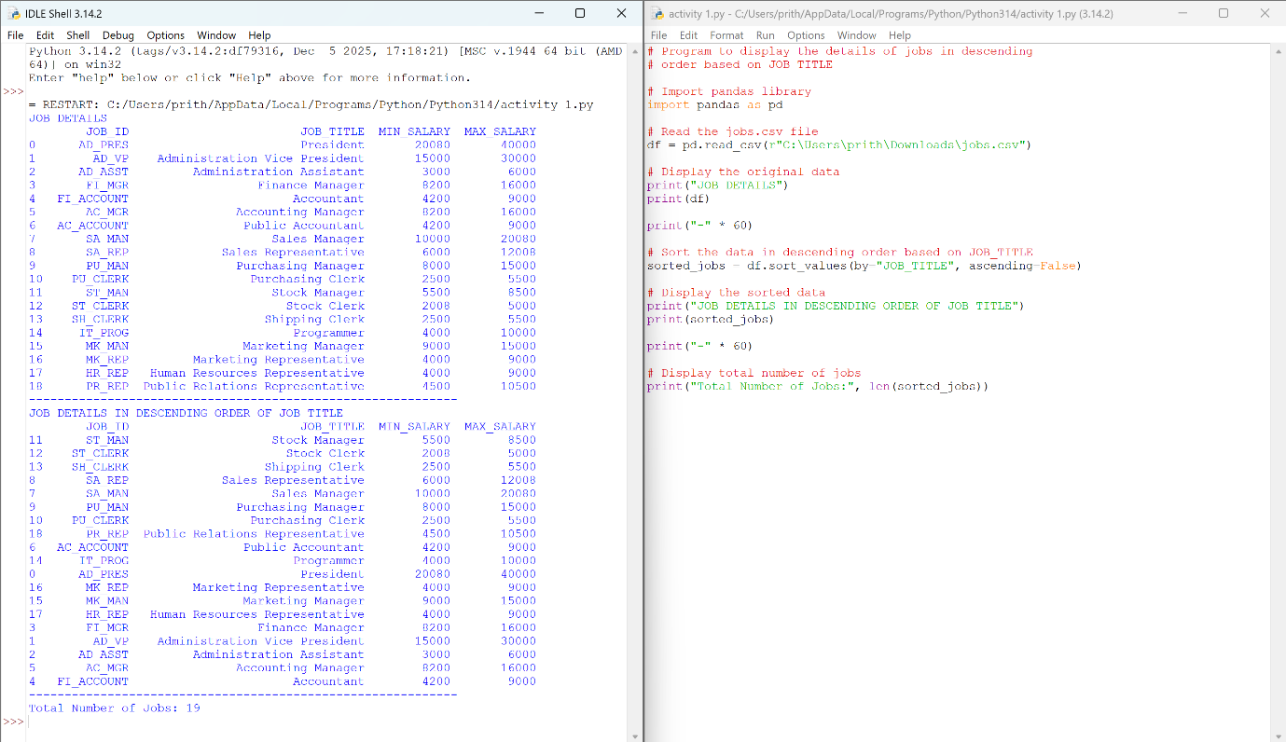
Result
The program successfully displayed the job details in descending order of the JOB_TITLE using the Pandas sort_values() function.

